SPARK: Simple Play Adaptations to Reference for Kids

Communicator Portable Waist – Loop Fabric Pages
Description: | Image:
Wearable communication notebook equipped with six, 4” x 8.5” VELTEX® Brand Fabric pages that accept Hook Fastener and two Hook and Loop tab closures for easy opening/closing. The outer cover of the book is made of durable nylon, available in six colors, has a zipper on the outside cover for personal items/extra pictures. The back of the cover of the Communicator has loops to fit any belt up to 2” wide.  *Belt not included-webbing belts sold separately. | 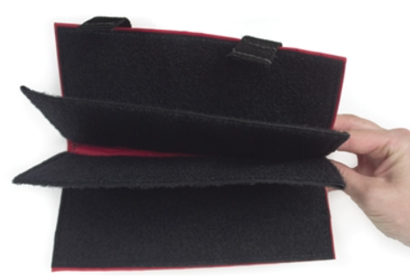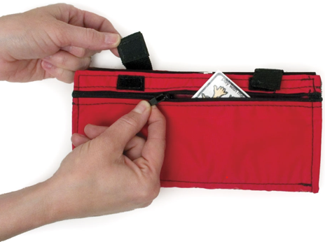  Purchasing Information

Who Might Benefit?
Those who…
• Need symbol support to express or receive information.
• Need a means of transporting their communication supports to have them available at all times.
Why Use?
Provides an opportunity to…
• Communicate with partners in many locations, especially in those not suitable for a more complex communication system.
• Have a wide variety of communication symbols available on six pages of 4” x 8.5” Velcro sensitive fabric available at all times.
• Wear the Communicator for easy access on the go. communication from single words to simple sentences.
Instructions for Use: | Adaptation Ideas:
Environmental Considerations  - Easily use in almost any environment because of the small size, weight, and easy transportability.  - If this particular style of communication is selected, make sure it is available is all child’s customary environments (e.g. home and school) to provide structure and routine, improve understanding, avoid frustration and offer opportunities to interact with others.  Positioning  - Use in most any position due to the size, portability, and minimal weight. It can be used on a table top, placed on the floor, positioned on a slant board, etc. A child could use it in positions such as sitting, standing, prone (Tummy Time position), supine (laying on their back), kneeling, etc. Provide at optimal viewing level and ensure its within reach of the child.  Basic Play/Use  - Introduce the Communicator with added symbol/visual support pages to the child and explain what you are going to be using it for.  - Be consistent in the use of visuals.  - Make Communicator accessible to everyone supporting the child (e.g. have a specific area for keeping it) and make sure everyone knows where it is.  Extended Play/Use  - Model use of the communicator. | Optional Additional Materials/Supplies  - Velcro  - Sheet protectors  - 3-ring binders with clear view covers  - Laminator and lamination sleeves  - Duct tape  Build It Up  - Build up for easy gripping or to provide high contrast.  Simplify It  - Start with only a few photos or visual symbols on each page based on the child's ability to understand and select responses, adding more as needed.  - Consider organizing pages by attribute (schedule, food choices, etc.)  Stabilize It  - Velcro to various surfaces in the environment as needed so it does not shift while the child is attempting to access it.  Add Sensory Cues  - Consider using high contrast visuals and/or contrasting background.  - Cut around the shapes of the visuals selected to be displayed and glue to high contrast background (ex: yellow or black paper).  - Tab/color code pages to help child locate what they want to say.  Alternative Uses  - Can be used to display schedules, task sequences, etc.  DIY Alternatives  - Create a wearable communication notebook from a 3-ring binder (3-ring binders come in a variety of sizes) and add a carrying strap.  - Cut and laminate various colored tabbed file folders  - Add strips of Velcro for attaching visuals  - Punch holes in pages and insert into notebooks  - Label tabs.  - Purchase double sided trading card collector sleeves (9 pockets to standard notebook sized sheets) and insert visuals into pockets. Place sheets in standard 3 ring binder.

Additional Considerations:
- Note: Not all children may tolerate wearing a communication support around their waist. The child and their communication partners should know how to fasten and unfasten the belt to remove Communicator if using the wearable option.

Resources:
- How to create low tech communication pictures
- Examples of good high contrast color schemes for low vision and why they are important

Note: Research has shown that early use of a communication device does not impact a child’s ability to develop oral speech later and will actually often help to enhance development of oral speech. See: Beyond Spoken Words :Augmentative and Alternative Communication (AAC).

